--Q1--

SELECT EMP.EMPNO AS EMP_NUMBER, EMP.ENAME AS FULL_NAME, EMP.SAL AS Salary, DEPT.DEPTNO AS DEPT_ID,DEPT.LOC AS Location

FROM DEPT JOIN EMP

ON DEPT.DEPTNO = EMP.DEPTNO

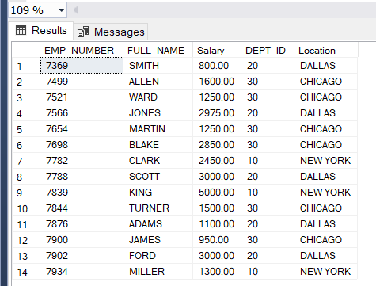

--Q2--

SELECT COUNT(EMPNO) AS NO_OF_EMP,DEPT.LOC AS LOCATION FROM EMP JOIN DEPT

ON DEPT.DEPTNO=EMP.DEPTNO

GROUP BY LOC

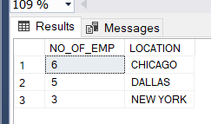

--Q3--

SELECT DEPT.* FROM DEPT INNER JOIN EMP

ON DEPT.DEPTNO=EMP.DEPTNO

WHERE EMP.SAL=(SELECT MAX(SAL) FROM EMP)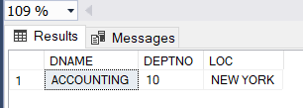

--Q4--

SELECT DEPT.*, AVG1.AVERAGE FROM DEPT JOIN

(SELECT DEPTNO, AVG(SAL) AS AVERAGE FROM EMP GROUP BY DEPTNO) AS AVG1 ON DEPT.DEPTNO = AVG1.DEPTNO;

